DESCON

###### DESCON ENGINEERING LIMITED

**225 MW BHIKKI POWER PLANT 25 KM SHAIKHUPURA FAISALABAD RAOD SHEIKHUPURA PAKISTAN TEL # +92 (056) 3679228**

**FAX # +92 (056) 3679227**

#### SERVICE CERTIFICATE

PP&A/FRM-29

Rev: 00

08-01-2021

**Sr. No: 1649 / 2889 / 1130**

Certified that Mr. <Name> Emp. No:

2889

N.I.C #

<CNIC>

Passport No: <Passport>

Son of Mr.

<fname> Resident of

DISTT. KHANEWAL, PAK

Nationality

PAKISTANI

Has served the company as

<Designation>

At DG CEMENT, DG KHAN .

From

<From> To

<To>

(Sporadically / Intermittently)

He left the job on his own accord.

His services were terminated due to

Completion of work

His services were no more required. He was revlieved fo the job on the completion of contract / job assignment / project.

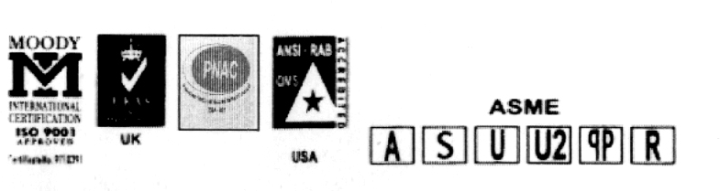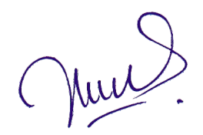

**GDMS Version : 2.7.12**

DESCON

Incharge P & A

**M**